How graphs can be represented in a data structure

In terms of representing graphs in a data structure, there are three ways that are possible, adjacency matrix, adjacency list and adjacency set.

Figure 1

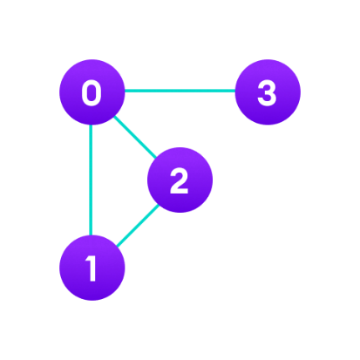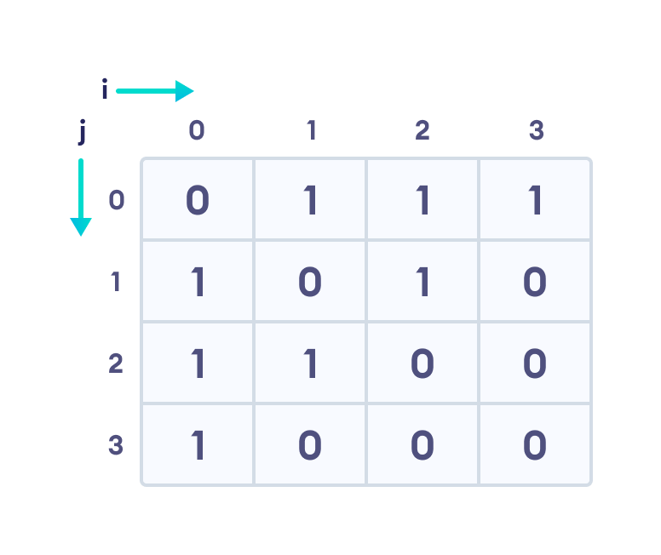

**Figure 2**

**Adjacency matrix:** an adjacency matrix is a table with rows and columns where each label from the row and columns represents a node. In figure 1, we can see that the number of rows, columns and nodes are the same. The zeros and ones represent whether there is a path to each node. For example, vertices 4 in the diagram on the left has three paths to vertices 1, 2 and 3, which means their value is represented as a one, whereas vertices 1 only has a path to vertices 4, leaving vertices 2 and 3 to have values of zero. We can also see this in figure 2, where vertices 0 has three paths to vertices 1, 2 and 3, but vertices 3 only has one path to vertices 0.

In figure 3, this is known as a directed graph, whereas figures 1 and 2 were undirected. This means that the connection is specified by the direction of the

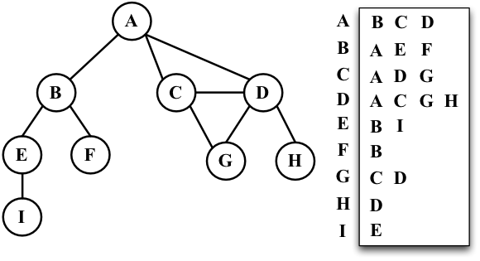

Figure 3

**Adjacency list:**

**Adjacency set:**

**Sources:**

https://www.mygreatlearning.com/blog/representing-graphs-in-data-structures